**what is Test Objective?**

**A Test Objective:** Refers to the specific goals or purposes that a testing process aims to achieve.

It defines what the testing is intended to validate or verify within a software application or system.

Clear test objectives help guide the testing process and ensure that all necessary aspects of the software are evaluated.

**Key Aspects of Test Objectives:**

1. **Validation of Requirements:** Ensures that the software meets the specified requirements and functions as intended.
2. **Quality Assurance:** Aims to identify defects or issues before the software is released, improving overall quality.
3. **Performance Evaluation:** Assesses how well the software performs under various conditions, including load and stress tests.
4. **User Experience:** Evaluates the usability and overall experience from the end user's perspective.
5. **Compliance:** Ensures that the software adheres to relevant standards, regulations, or policies.

**Examples of Test Objectives:**

**To Verify** that the login functionality operates correctly under different user scenarios.

**To Check** the application's performance under peak load conditions.

**To Ensure** that all security measures are in place and effective.

**What is Test Environment?**

**A Test Environment** is a setup that mimics the production environment where a software application will eventually run. It includes the hardware, software, network configurations, and tools necessary for executing tests and validating the application’s performance, functionality, and security.

**Components of a Test Environment:**

1. **Hardware:** The physical machines or virtual servers on which the application runs. This may include computers, servers, or cloud instances.
2. **Software:** All necessary software components, including the operating system, application servers, databases, and any third-party applications or services that the application interacts with.
3. **Network Configuration:** The setup of network conditions, including firewalls, routers, and virtual private networks (VPNs), to simulate real-world usage scenarios.
4. **Test Data:** Data used during testing, which may include production-like datasets, user accounts, and configurations.
5. **Testing Tools:** Tools for automation, performance testing, and defect tracking that facilitate the testing process.

**Types of Test Environments:**

**Development Environment:** Used by developers for initial testing and debugging.

**Staging Environment:** A replica of the production environment used for pre-release testing.

**Production Environment:** The live environment where the application is available to users.

**Importance of a Test Environment:**

**Realistic Testing:** Provides a controlled setting that closely resembles the actual operating conditions.

**Issue Identification:** Helps in identifying bugs and issues that may not manifest in a different environment.

**Risk Mitigation:** Reduces the risk of post-deployment failures by ensuring thorough testing is conducted.

* **Example 1:**
* **Basic Functionality Test Cases For Calculator:**

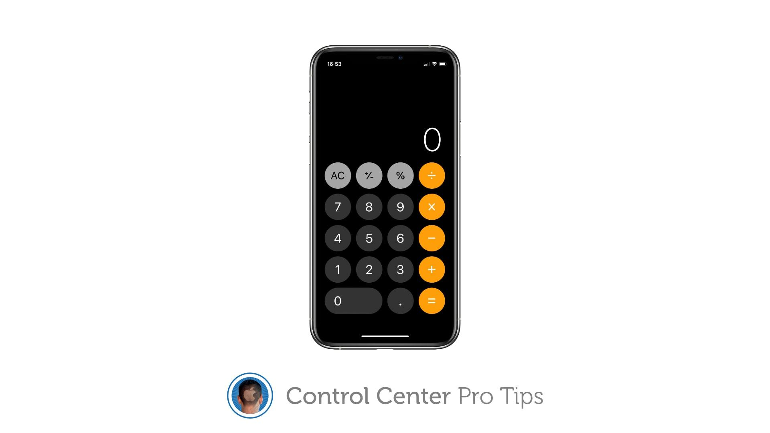

1. **Add one or more numbers and verify the calculated result when you hit =.**
2. **Subtract one or more numbers and verify the calculated result when you hit =.**
3. **Multiply one or more numbers and verify the calculated result when you hit =.**
4. **Divide a few numbers and verify the calculated result when you hit =.**
5. **Add, subtract, and multiply using a negative number when you hit =.**
6. **Add, subtract, multiply, and divide by numbers with decimals(3.6) when you hit =.**
7. **Test the AC button clears the last entry.**

**TEST CASES**

|  |  |  |  |  |  |  |  |  |  |  |  |  |  |
| --- | --- | --- | --- | --- | --- | --- | --- | --- | --- | --- | --- | --- | --- |
| |  |  | | --- | --- | | **Project Name** | …………………………………… | | **Description** | ……………………………………. | | |  |  | | --- | --- | | **Test Case Author :** | **…….** | | **Test Case Reviewer :** | **…….** | | **Test Case Version** | **…….** | | **Test Execution Date :** | **…….** | |

**Test Scenarios:**

1. Addition

2. Subtraction

3. Multiplication

4. Division

5. AC button

6. Equal button

|  |  |  |  |  |  |  |  |  |
| --- | --- | --- | --- | --- | --- | --- | --- | --- |
| **Test Case ID** | **Test Case**  **Description** | **Test Steps** | **Input Data** | **Expected Results** | **Actual Results** | **Execution Status** | **Test Environment** | **Bug Priority** |
| **1** | **Add 2 positive numbers** | **- Insert 2 positive numbers (num1 and num2)**  **-And operation (+)** | **Num1= 4**  **Num2= 5** | **result= 9** | **result = 4** | **Not Pass** | **Test Data** | **High** |
| **2** | **Add 2 negative numbers** | **-insert 2 negative numbers**  **numbers (num1 and num2)**  **-And operation ( + )** | **Num1= (- 9)**  **Num2= (- 3)** | **result = (-12)** | **result = -9** | **Not Pass** | **Test Data** | **High** |
| **3** | **Add 2 numbers**  **(negative , positive)** | **-insert 1 negative number**  **- insert 1 positive number**  **numbers (num1 and num2)**  **-And operation ( + )** | **Num1= (- 9)**  **Num2= (3)** | **result = ( -6 )** | **result = -9** | **Not Pass** | **Test Data** | **High** |
| **4** | **Add 2 numbers**  **( positive, negative)** | **-insert 1 positive number**  **- insert 1 negative number**  **numbers (num1 and num2)**  **-And operation ( + )** | **Num1= (9)**  **Num2= (- 3)** | **result = ( 6 )** | **result = 9** | **Not Pass** | **Test Data** | **High** |
| **5** | **Sub 2 positive numbers** | **Insert 2 positive numbers (num1 and num2)**  **-And operation ( - )** | **Num1= 4**  **Num2= 2** | **Sub=2** | **Sub=2** | **Pass** | **Test Data** | **High** |
| **6** | **Sub 2 negative numbers** | **-insert 2 negative numbers**  **numbers (num1 and num2)**  **-And operation ( - )** | **Num1= (-4)**  **Num2= (-2)** | **Sub= -2** | **Sub= -2** | **Pass** | **Test Data** | **High** |
| **7** | **Sub 2 numbers**  **(negative , positive)** | **-insert 1 negative number**  **- insert 1 positive number**  **numbers (num1 and num2)**  **-And operation ( - )** | **Num1= (-4)**  **Num2= (2)** | **Sub= -6** | **Sub= -6** | **Pass** | **Test Data** | **High** |
| **8** | **Sub 2 numbers**  **( positive, negative)** | **-insert 1 positive number**  **- insert 1 negative number**  **numbers (num1 and num2)**  **-And operation ( - )** | **Num1= (4)**  **Num2= (-2)** | **Sub= 6** | **Sub= 6** | **Pass** | **Test Data** | **High** |
| **9** | **Multiply 2 positive numbers** | **Insert 2 positive numbers (num1 and num2)**  **-And operation ( * )** | **Num1= 6**  **Num2= 3** | **Mul=18** | **Mul=18** | **Pass** | **Test Data** | **High** |
| **10** | **Multiply 2 negative numbers** | **-insert 2 negative numbers**  **numbers (num1 and num2)**  **-And operation ( * )** | **Num1= (-6)**  **Num2= (-3)** | **Mul= 18** | **……………** | **……………** | **Test Data** | **High** |
| **11** | **Multiply 2 numbers**  **(negative , positive)** | **-insert 1 negative number**  **- insert 1 positive number**  **numbers (num1 and num2)**  **-And operation ( * )** | **Num1= (-6)**  **Num2= 3** | **Mul= -18** | **……………** | **……………** | **Test Data** | **High** |
| **12** | **Multiply 2 numbers**  **( positive, negative)** | **-insert 1 positive number**  **- insert 1 negative number**  **numbers (num1 and num2)**  **-And operation ( * )** | **Num1= 6**  **Num2= (-3)** | **Mul= -18** | **……………** | **……………** | **Test Data** | **High** |
| **13** | **divide 2 positive numbers** | **-Insert 2 positive numbers (num1 and num2)**  **-And operation ( / )** | **Num1=9**  **Num2=3** | **Div=3** | **Div=9** | **Not Pass** | **Test Data** | High |
| **14** | **divide 2 negative numbers** | **-insert 2 negative numbers**  **numbers (num1 and num2)**  **-And operation ( / )** | **………….** | **…………** | **………..** | **………….** | **Test Data** | High |
| **15** | **divide 2 numbers**  **(negative , positive)** | **-insert 1 negative number**  **- insert 1 positive number**  **numbers (num1 and num2)**  **-And operation ( / )** | **………….** | **…………** | **………..** | **………….** | **Test Data** | High |
| **16** | **divide 2 numbers**  **( positive, negative)** | **-insert 1 positive number**  **- insert 1 negative number**  **numbers (num1 and num2)**  **-And operation ( / )** | **………….** | **…………** | **………..** | **………….** | **Test Data** | High |
| **17** | **Test the AC button clears** | **Click AC Button** | **Click AC Buttons** | **Clear** | **Clear** | **Pass** | **Software** | Medium |
| **18** | **Test the Equal button** | **Click Equal Button** | **Click Equal Button** | **Show Result** | **Show Result** | **Pass** | **Software** | High |